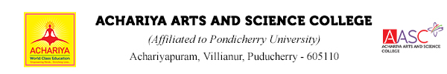

Department of Mathematics – Activity Report
Happy Greetings
With full happiness the department of mathematics shares with you about the successful completion of the program today (24.11.23) titled, "Fake Feminism - A talk on Women empowerment" By Mrs. Vaijainthimala Valarmathi, MBA., LLB., M. Sc. Psychology, Advocate and District Vice President, Mahila Morcha, Thiruvallur West, TN BJP.

The program started with a welcome address by A. Diana Vinster Nadeen, Head in charge, Assistant professor, Department of Mathematics.

Dr. T. Janarthanan, Vice Principal, Head, Department of English honoured the chief Guest and gave the presidential address and then the session was handed over to the chief Guest.

She gave an interactive and thought provoking speech which created a clear understanding about what feminism really means? And how are we consuming it in a wrong notion.

By the end of the program we received positive feedback from students followed by a Gratitude note by Mrs. P. Dhiviya, Assistant professor, Department of Mathematics.

In this regard we thank our principal Dr. V. Shanmugaraju for his fullest support in all our endeavours.

We thank all the department heads for their kind cooperation in sending their first year girl students.

We thank our physical education team for their hand in the maintenance of students’ discipline.

We thank the Visual Communication team for helping in the digitalization of the event.

We thank our office team, maintenance team and housekeeping team for their fine hospitality.

Thank you one and all.
With regards
- Diana Vinster Nadeen,
Head In-charge,
Assistant professor,
Department of Mathematics,
Achariya Arts and Science College,
Puducherry

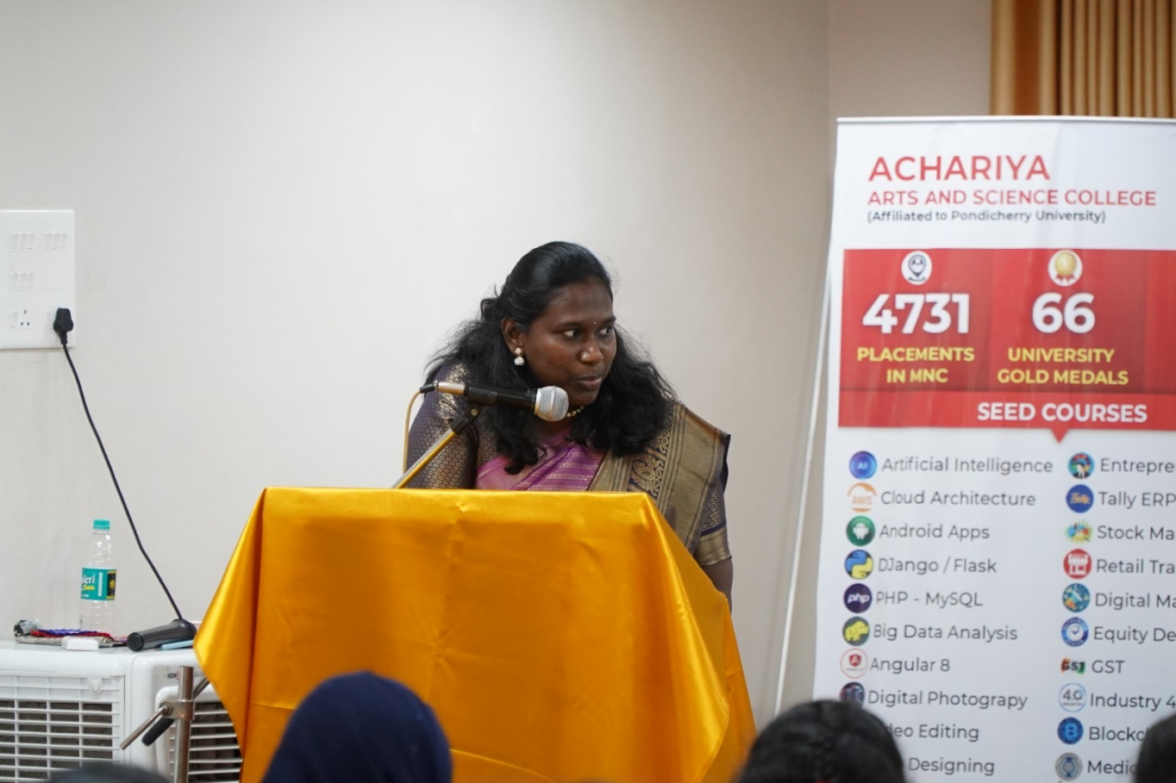

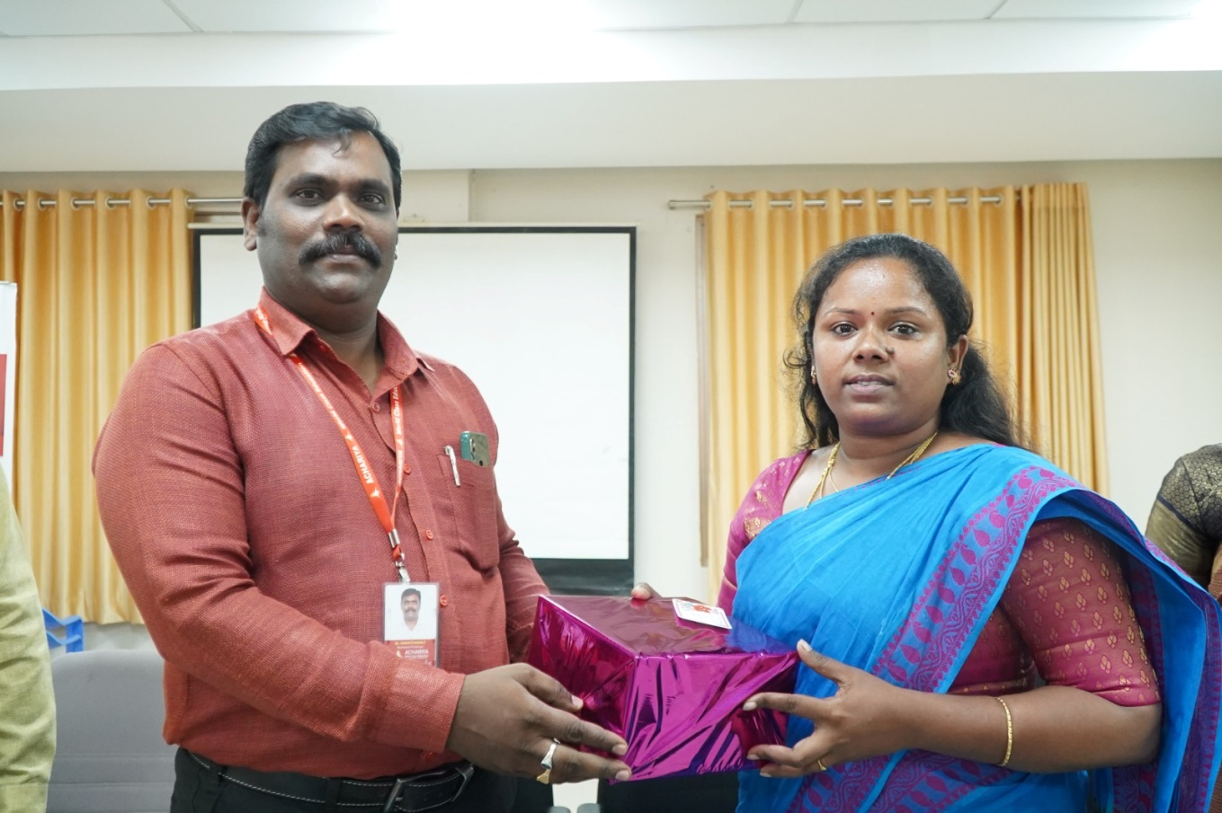

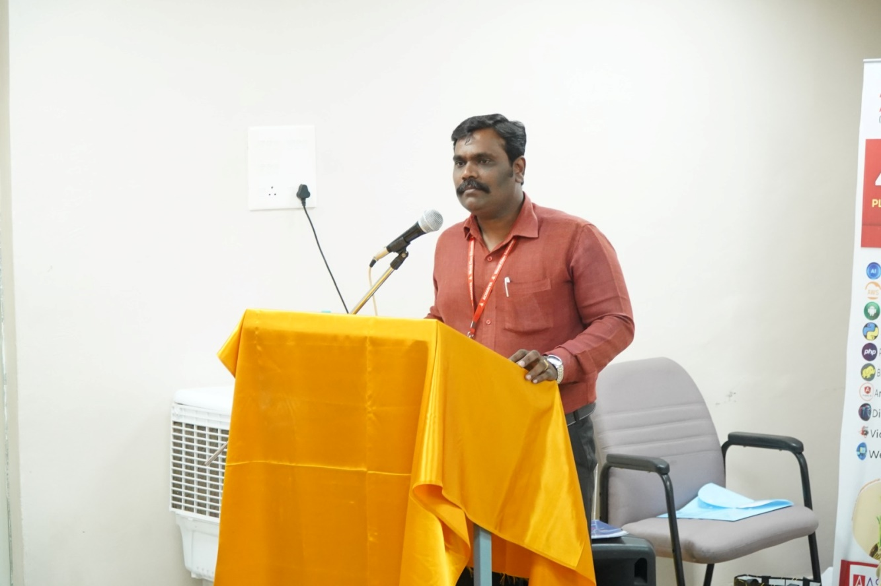

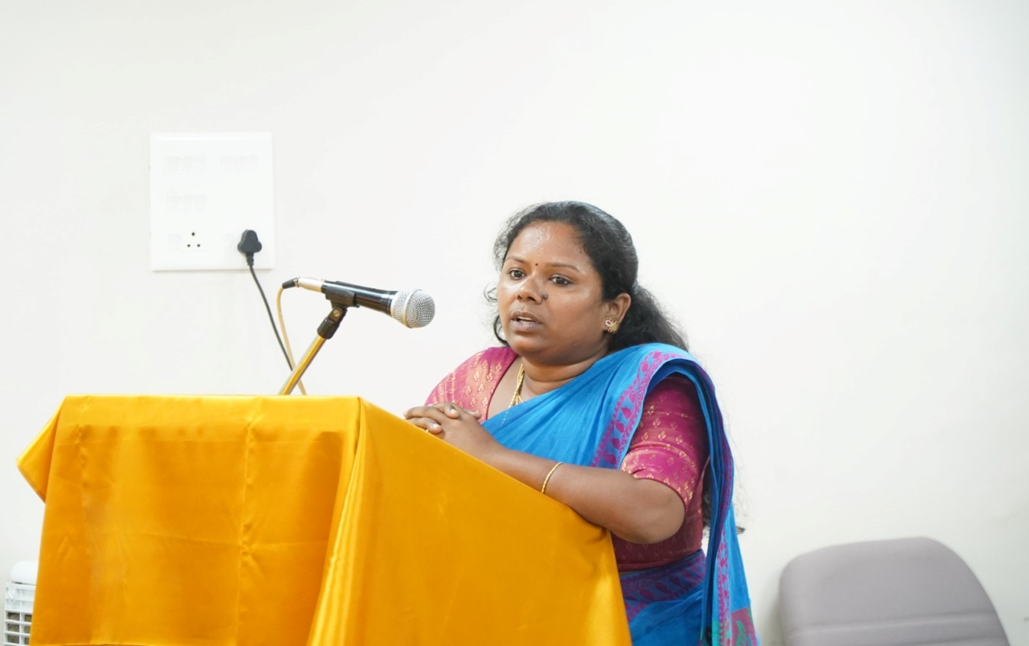

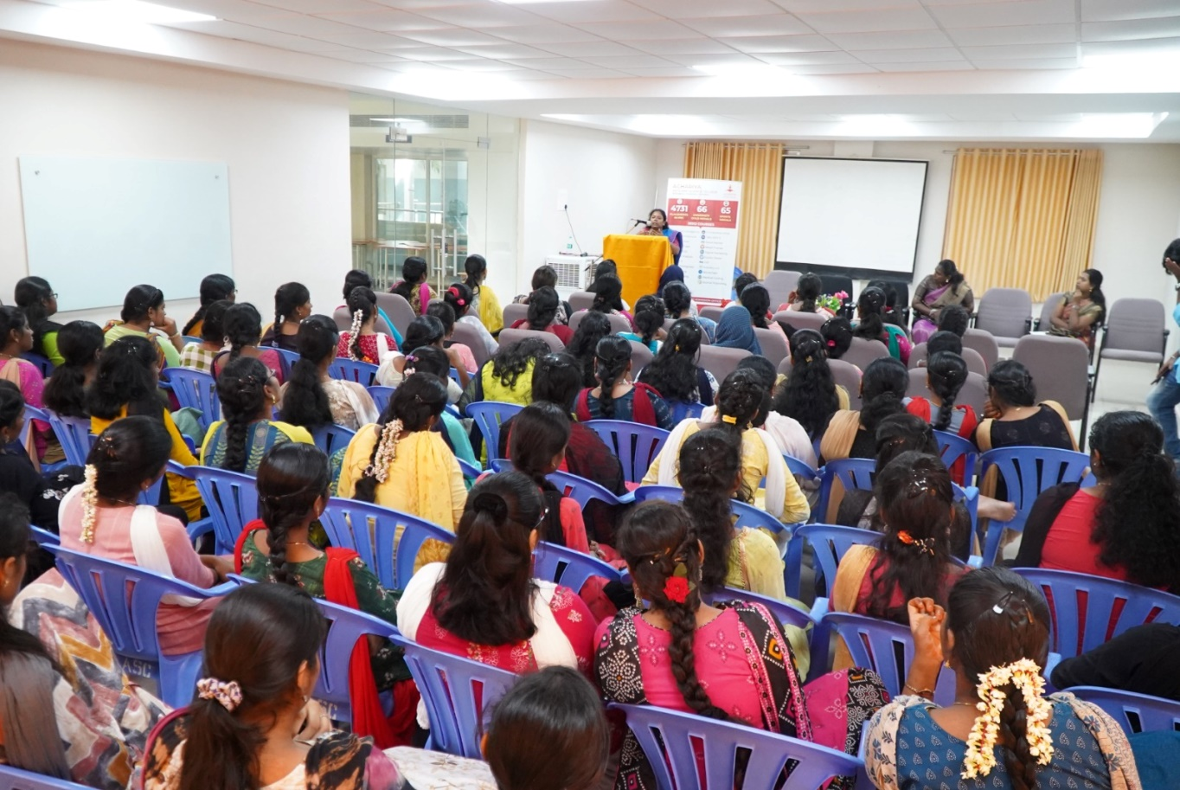

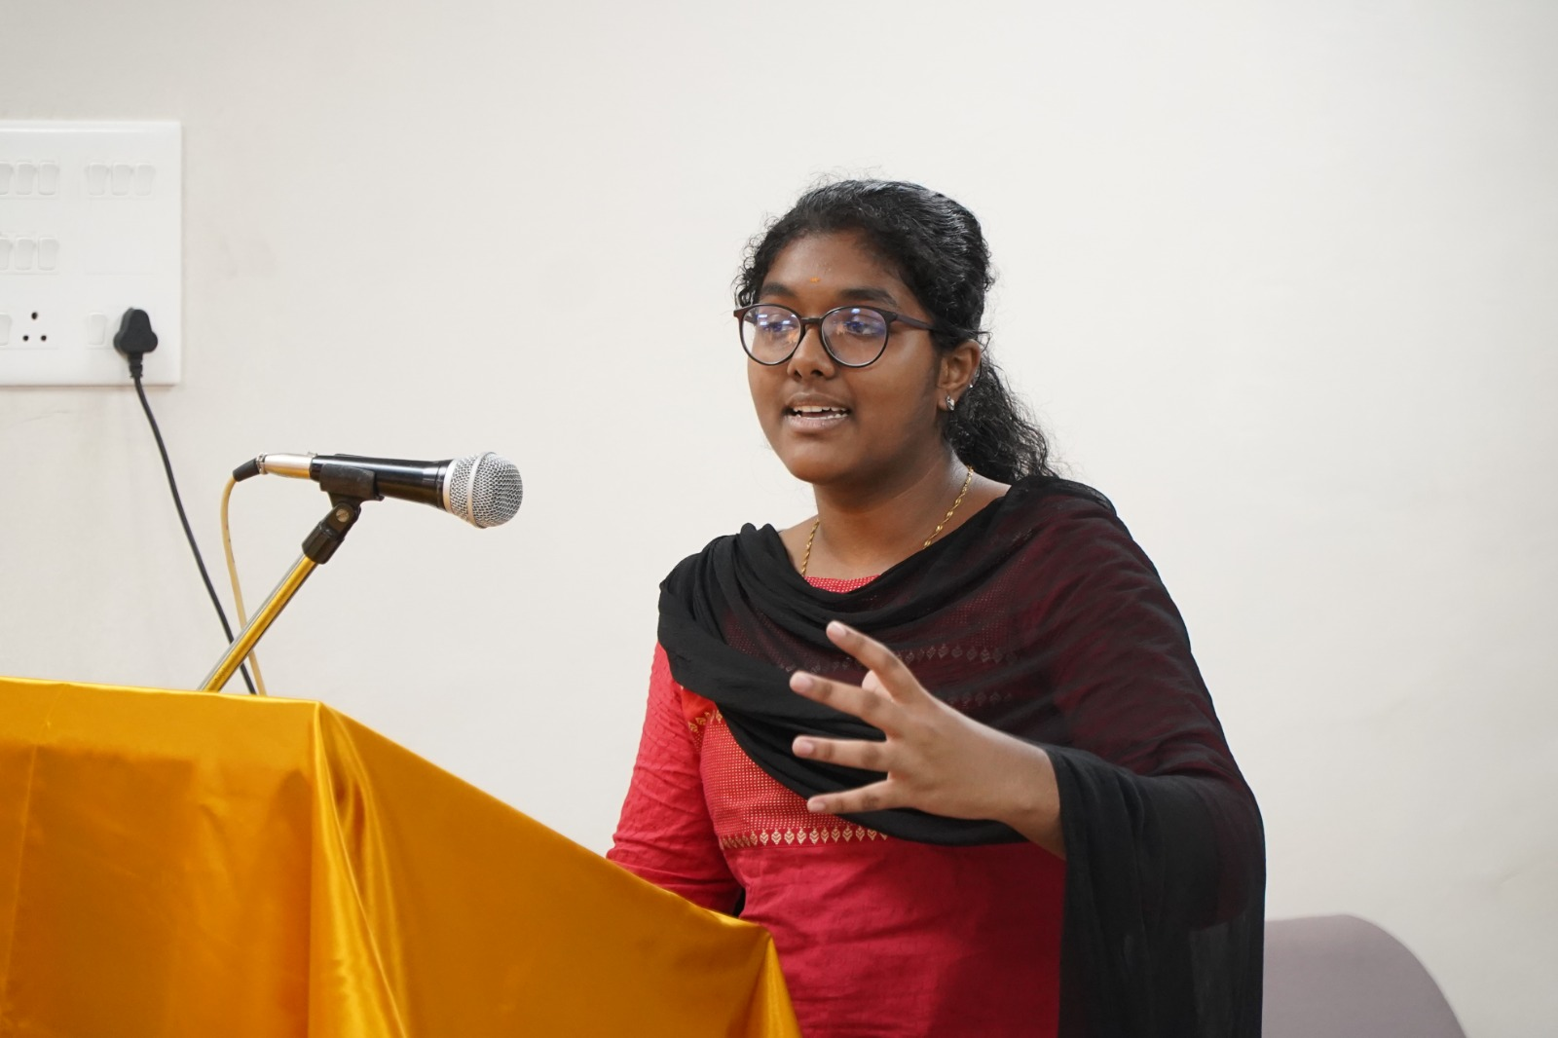

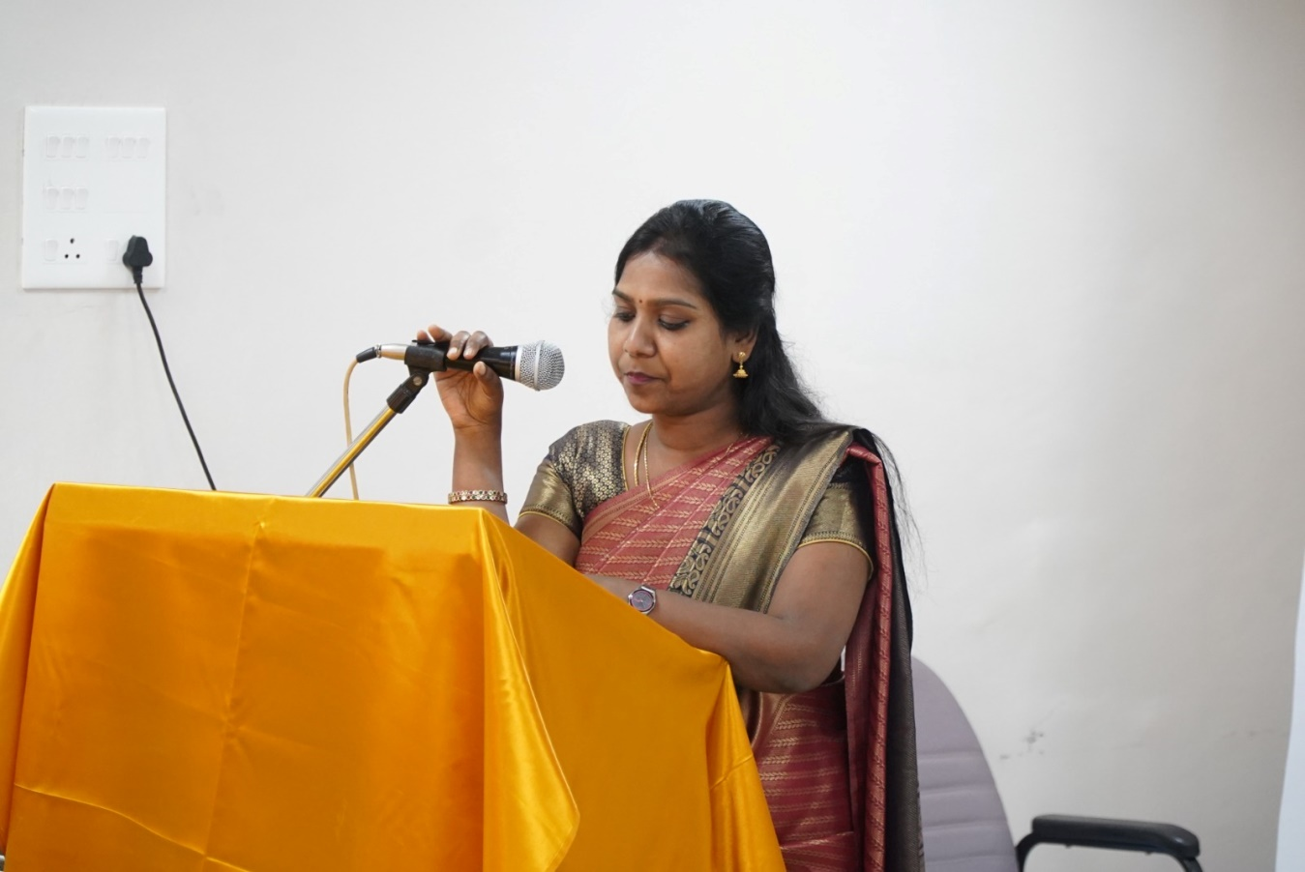
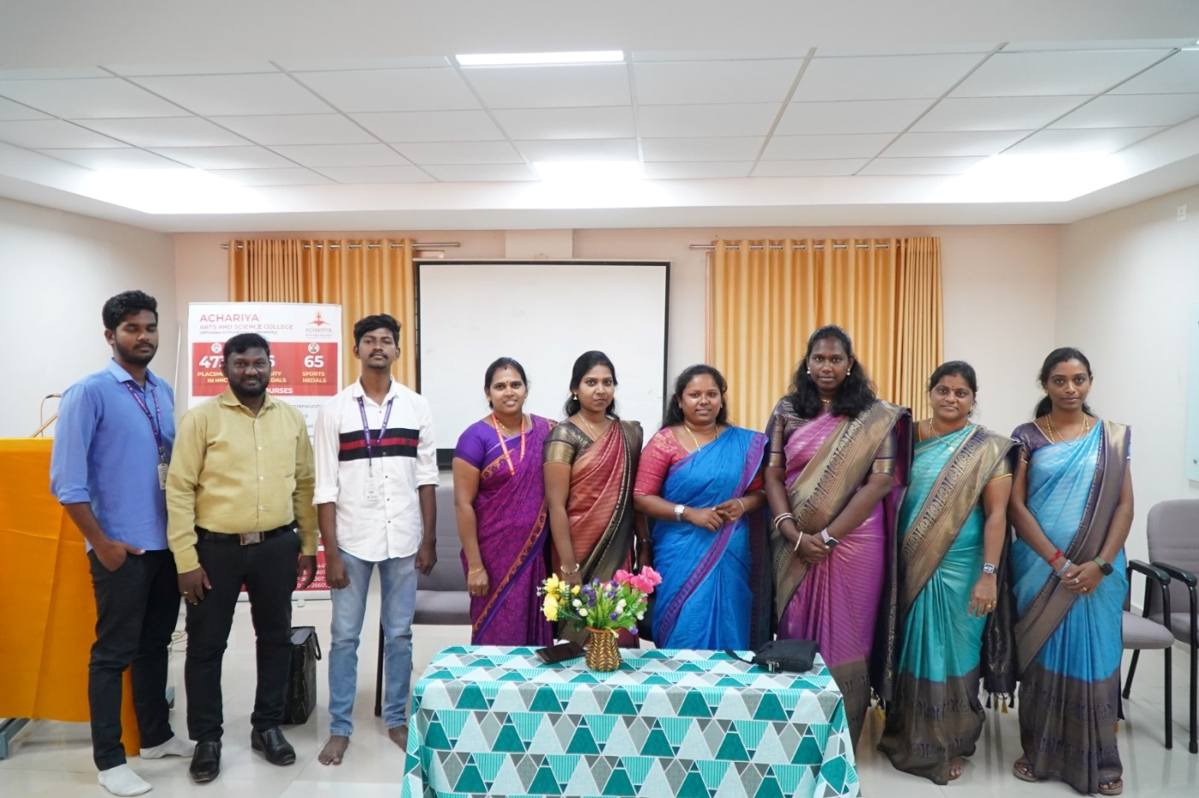

HOD PRINCIPAL

